Ex. No. 10 | Working with MongoDB using shell commands
Date of Exercise | 12.10.2026
GitHub Host Link | EXP 10

Aim
To demonstrate database creation, document insertion, querying, updating, indexing, and deletion in a document-oriented NoSQL database using MongoDB Shell (mongosh) commands.
Description
MongoDB is a popular NoSQL document database designed for high availability, performance, and dynamic schema scalability.
MongoDB Shell (mongosh) is an interactive JavaScript interface used to interact with MongoDB instances.
The following operations were implemented:
S.No. | Operation | Description
1 | Database and Collection Management | Listing databases, switching databases and creating collections.
2 | Create Operations | Inserting single and multiple documents using insertOne() and insertMany().
3 | Read Operations | Retrieving documents using filters, comparison operators, logical operators, projections and counts.
4 | Update Operations | Modifying documents using $set, $push and $inc.
5 | Indexing | Creating and verifying a unique index using createIndex() and getIndexes().
6 | Delete Operations | Removing documents using deleteOne() and deleteMany().
Program

File: experiment10.mongodb.js
console.log("============================================================================");
console.log("EXPERIMENT 10: MONGODB SHELL COMMANDS EXECUTION");
console.log("============================================================================");

// SECTION 1: DATABASE AND COLLECTION MANAGEMENT

console.log("\n--- SECTION 1: Database and Collection Management ---");

// List all databases
const dbsResult = db.adminCommand({ listDatabases: 1 });
dbsResult.databases.forEach(d => console.log(d.name));

// Switch to universityDB
const targetDB = db.getSiblingDB("universityDB");
console.log("Active database:", targetDB.getName());

// Create students collection safely
const existingCollections = targetDB.getCollectionNames();

if (existingCollections.includes("students")) {
const count = targetDB.students.countDocuments();

if (count > 0) {
targetDB.students.drop();
targetDB.createCollection("students");
}
} else {
targetDB.createCollection("students");
}

// Display collections
console.log("Collections:", targetDB.getCollectionNames());

// SECTION 2: CREATE OPERATIONS

console.log("\n--- SECTION 2: Create Operations ---");

// Insert one document
const insertOneResult = targetDB.students.insertOne({
student_id: 101,
name: "Aarav Sharma",
age: 20,
major: "Computer Science",
gpa: 3.85,
skills: ["Python", "SQL", "JavaScript"],
enrollmentDate: new Date("2023-08-15")
});

console.log("Inserted ID:", insertOneResult.insertedId);

// Insert multiple documents
const insertManyResult = targetDB.students.insertMany([
{
student_id: 102,
name: "Bhavna Patel",
age: 21,
major: "Information Technology",
gpa: 3.65,
skills: ["Java", "HTML", "CSS"],
enrollmentDate: new Date("2022-08-15")
},
{
student_id: 103,
name: "Chetan Kumar",
age: 22,
major: "Computer Science",
gpa: 3.92,
skills: ["C++", "Python", "Docker"],
enrollmentDate: new Date("2021-08-15")
},
{
student_id: 104,
name: "Divya Nair",
age: 19,
major: "Data Science",
gpa: 3.40,
skills: ["R", "Python", "Tableau"],
enrollmentDate: new Date("2024-08-15")
}
]);

console.log("Inserted documents:",
Object.keys(insertManyResult.insertedIds).length);

console.log("Total students:",
targetDB.students.countDocuments());

// SECTION 3: READ OPERATIONS

console.log("\n--- SECTION 3: Read Operations ---");

// Retrieve all documents
console.log("All students:");
console.log(targetDB.students.find().toArray());

// Exact-match query
console.log("Computer Science students:");
console.log(targetDB.students.find({
major: "Computer Science"
}).toArray());

// Comparison query using $gte
console.log("Students with GPA >= 3.70:");
console.log(targetDB.students.find({
gpa: { $gte: 3.70 }
}).toArray());

// Logical $or and array matching
console.log("Information Technology students OR students with Python:");

console.log(targetDB.students.find({
$or: [
{ major: "Information Technology" },
{ skills: "Python" }
]
}).toArray());

// Projection query
console.log("Selected student fields:");

console.log(targetDB.students.find(
{},
{ _id: 0, name: 1, gpa: 1, major: 1 }
).toArray());

// Retrieve a single document
console.log("Student 101:");

console.log(targetDB.students.findOne({
student_id: 101
}));

// Count matching documents
console.log("Computer Science student count:");

console.log(targetDB.students.countDocuments({
major: "Computer Science"
}));

// SECTION 4: UPDATE OPERATIONS

console.log("\n--- SECTION 4: Update Operations ---");

// Update one document using $set
const updateOneResult = targetDB.students.updateOne(
{ student_id: 101 },
{ $set: { gpa: 3.95 } }
);

console.log("Updated student 101:",
updateOneResult.modifiedCount);

// Update multiple documents using $push
const updateManyResult = targetDB.students.updateMany(
{ major: "Computer Science" },
{ $push: { skills: "Git" } }
);

console.log("Updated Computer Science students:",
updateManyResult.modifiedCount);

// Increment age using $inc
const incResult = targetDB.students.updateOne(
{ student_id: 102 },
{ $inc: { age: 1 } }
);

console.log("Incremented student 102 age:",
incResult.modifiedCount);

// Verify updated documents
console.log("Updated student records:");

console.log(targetDB.students.find(
{ student_id: { $in: [101, 102, 103] } },
{ _id: 0, student_id: 1, name: 1, age: 1, gpa: 1, skills: 1 }
).toArray());

// SECTION 5: INDEXING

console.log("\n--- SECTION 5: Indexing ---");

// Create unique ascending index
const indexName = targetDB.students.createIndex(
{ student_id: 1 },
{ unique: true }
);

console.log("Created index:", indexName);

// Display indexes
console.log("Collection indexes:");

console.log(targetDB.students.getIndexes());

// Verify index usage
const explainStats = targetDB.students.find({
student_id: 101
}).explain("executionStats");

console.log("Query execution statistics:");
console.log(explainStats.executionStats);

// SECTION 6: DELETE OPERATIONS

console.log("\n--- SECTION 6: Delete Operations ---");

// Delete one document
const deleteOneResult = targetDB.students.deleteOne({
student_id: 104
});

console.log("Deleted documents:", deleteOneResult.deletedCount);

// Delete multiple documents using $lt
const deleteManyResult = targetDB.students.deleteMany({
gpa: { $lt: 3.70 }
});

console.log("Deleted documents:", deleteManyResult.deletedCount);

// Verify remaining documents
console.log("Remaining student records:");

console.log(targetDB.students.find(
{},
{ _id: 0, student_id: 1, name: 1, major: 1, gpa: 1, age: 1 }
).toArray());

console.log("Remaining student count:",
targetDB.students.countDocuments());

// SECTION 7: OPTIONAL CLEANUP

console.log("\n--- CLEANUP INSTRUCTIONS ---");
console.log("Cleanup commands are not executed automatically.");
console.log("After verification, run manually if required:");
console.log("targetDB.students.drop();");
console.log("targetDB.dropDatabase();");

console.log("\nALL EXPERIMENT 10 OPERATIONS COMPLETED SUCCESSFULLY!");
Output
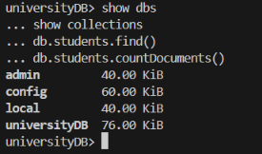
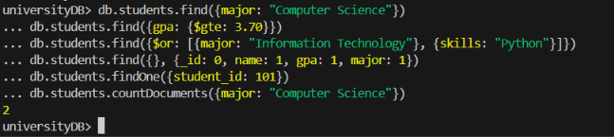
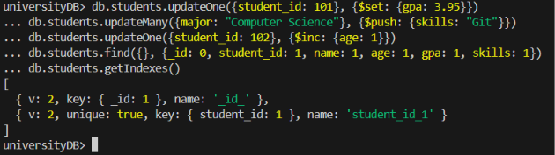
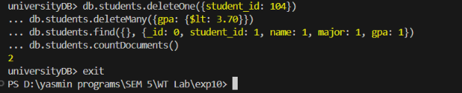

Result
Thus, the MongoDB practical was successfully executed using MongoDB Shell (mongosh). Database and collection creation, document insertion, querying, updating, indexing and deletion operations were demonstrated and verified successfully.

